|  |  |
| --- | --- |
|  | **M.Sc. IT**  **Semester-III**  **PROJECT III**  **(ITCC13)** |

**A Project Report on**

**Online Backup System**

Submitted as partial fulfillment of the requirement

for M.Sc**.(IT) - Semester III**

Prepared for Subject: **PROJECT III** (ITCC13)

**Prepared By**

**Name of Student : Gaurav Zalavadiya**

**Enrollment No. : 22MSCIT22015**

**Name of Student : Kotharia Samir**

**Enrollment No. : 22MSCIT22016**

**Name of Student : Deep Patel**

**Enrollment No. : 22MSCIT22018**



Shri Maneklal M. Patel Institute of Sciences and Research**,**

**Department of M.Sc. (IT), Gandhinagar.**

Shri Maneklal M. Patel Institute of Sciences and Research**,**



**Department of M.Sc. (IT), Gandhinagar.**

Date:

**PROJECT WORK CERTIFICATE**

This is to certify that the project report submitted by ***Gaurav Zalavadiya*, *Deep Patel, Kotharia Samir*** having enrollment no.22MSCIT22015, 22MSCIT22016, 22MSCIT22018, a student of **M.Sc.(IT) Semester- III** has completed his/her project titled “***Online Backup System”*** satisfactorily during the academic year 2022.

We appreciate the enthusiasm & dedication towards work submitted.

**Prof. B. R. Pandya**

Head of Department, M.Sc. IT, Gandhinagar

Kadi Sarva Vishwavidyalaya

**Internal Project Guide**

Ms. Snehal Mam

M.Sc. IT, Gandhinagar

Kadi Sarva Vishwavidyalaya

**ACKNOWLEDGMENT**

I am grateful to my internal guide **Ms. Snehal Rindani** for providing me valuable guidance for the PROJECT III and other domain related information.

Also my hearty gratitude to Head of Department, **Prof. (Dr.) B. R. Pandya** for giving me an opportunity for learning through the process of Project III by which I can improve my technical skills along with practical exposure and its applicability in the industry.

**Name of Student: Signature of Student:**

**Gaurav Zalavadiya**

**Kotharia Samir**

**Deep Patel**

**Enrollment No.: 22mscit22015, 22mscit22016, 22mscit22018**

**INDEX**

|  |  |  |
| --- | --- | --- |
| **Sr. No.** | **Topic** | **Page No.** |
| 1. | Introduction | 5 |
| 2. | Scope | 6 |
| 3. | Objective | 7 |
| 4. | Functional Reruirement | 8 |
| 5. | System Archiotecture, Tools &Technology | 10 |
| 6. | Entity Relationship Diagram  Data Dictionary | 11 |
| 7. | coding | 15 |
| 8. | Testing | 22 |
| 9. | Screen layouts | 23 |
| 10. | Future Enhancement | 27 |

**Online Backup system**

**Introduction**

An online backup system, also commonly referred to as cloud backup or remote backup, is a critical component of modern data management and protection strategies. It provides individuals and organizations with a secure and convenient method for safeguarding their digital assets, ensuring data availability, and recovering information in case of data loss or disasters.

This data can include files, documents, photos, videos, databases, and more. Online backup systems offer a reliable and convenient way to safeguard important information from various risks, including hardware failures, data corruption, accidental deletion, and disasters such as fires or floods.

In the digital age, where data plays an integral role in personal and business operations, protecting valuable information from loss or corruption is of paramount importance. Online backup systems offer a robust solution to address this need.

Online backup systems are designed to automatically and securely copy data from local devices, such as computers, servers, or mobile devices, to remote data centers hosted by third-party providers. This redundancy ensures that data remains accessible even if the original device experiences hardware failures, theft, accidental deletion, or other catastrophic events.

5

**Scope**

The scope of online backup systems is continually expanding due to the increasing importance of data in both personal and professional contexts. As technology evolves and data volumes continue to grow, the scope of online backup systems widens to encompass a range of applications and industries.   
  
Here's an overview of the broad scope and potential areas of growth for online backup systems:

* The scope of an online backup system involves providing a secure and reliable method to store and restore digital data.
* This includes backing up various types of files, ensuring data, offering user-friendly interfaces, supporting backups, and implementing measures to protect against data breaches and loss.
* The system's scope may also extend to managing different backup versions, offering scalability, and facilitating efficient data recovery.
* The system should support a wide range of data, including documents, images, code files, and databases.
* The system should be designed to accommodate the growth of data over time, allowing users to upgrade storage space as needed.
* An easy-to-use interface is crucial for managing backups, restoring data.

6

**Objective**

The primary objectives of an online backup system, also known as a cloud backup system, are to ensure the protection, availability, and recoverability of digital data. These systems aim to address various challenges and risks associated with data management, including data loss, data corruption, hardware failures, and disasters.

Here are the key objectives of an online backup system:

* The objective of an online backup system project is to develop a reliable platform that allows users to back up their digital data (such as files, documents, photos) to servers over the internet.
* This ensures data preservation, disaster recovery, and easy access from server.
* The system should provide features like data backups, efficient storage utilization, and user-friendly interfaces.
* Ensure the ability to recover lost or corrupted data quickly and efficiently, minimizing downtime and disruptions.
* Ensure the ability to preserve project-related data for future reference.

7

**Functional Requirements**

1.**User Authentication and Authorization:**

- Users should be able to create accounts, log in, and manage their profiles.

- Different levels of access should be implemented based on user roles

2. **Project Backup and Restore:**

- Users should be able to initiate manual backups of their projects.

- Backups should be available such as files, documents, photos.

3. **Storage Management:**

- Storage space should be allocated for each user's backups.

- Storage quotas should be enforced to prevent abuse.

4.**User-Friendly Interface:**

- The user interface should be intuitive and easy to navigate.

- Clear instructions should be provided for each functionality.

5. **Notification System:**

- Users should receive notifications about the status of backups (successful, failed, etc.).

8

- Alerts should be sent for critical issues like failed backups or storage nearing capacity.

6. **Documentation and Help:**

- Provide user documentation and help resources (e.g., FAQs, tutorials).

7**. Security Measures:**

**-** Implement security features like input validation, authentication, authorization, and protection against common web vulnerabilities (e.g., XSS, CSRF, SQL injection).

9

**System Architecture,Tools & Technology**

**Hardware Requirements:**

* Intel(R) Core(TM) i5-3360M CPU @ 2.80GHz 2.80 GHz
* Any version of Windows XP or later.
* Processor speed: 2.0 GHz
* RAM : 4GB
* Hard disk: 40GB to 80 GB

**Software Requirements:**

* Database : SQL
* Server : SQL Server
* Frontend : CSS,HTML,Bootstrap
* Scripting Language : C#
* Technology : .Net

10

**Entity Relationship Diagram**

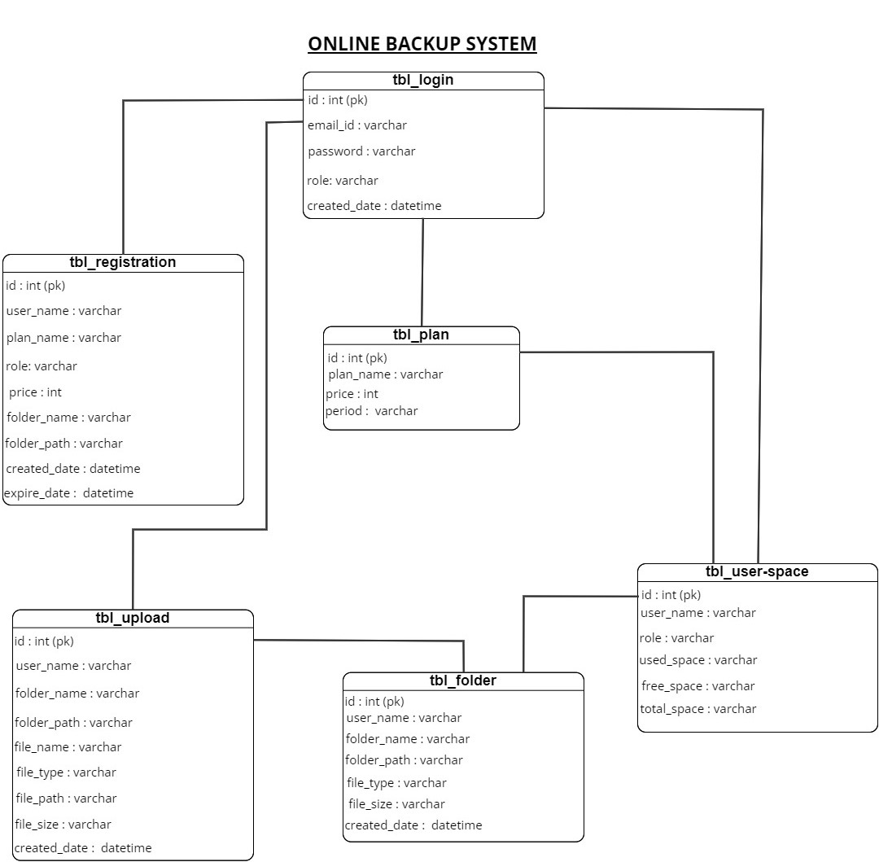

11

**Data Dictionary**

**Table name : Login**

|  |  |  |  |  |
| --- | --- | --- | --- | --- |
| No. | Name | Datatype | Null | Constraint |
| 1 | Id | int | Primary key | Store user id |
| 2 | Email_id | Varchar(40) | Not null | Store email_id |
| 3 | Password | Varchar(10) | Not null | Store password |

**Table name : Registraion**

|  |  |  |  |  |
| --- | --- | --- | --- | --- |
| No. | Name | Datatype | Null | Constraint |
| 1 | Id | int | Primary key | Store user id |
| 2 | User_name | Varchar(15) | Not null | Store user name |
| 3 | Plan_name | Varchar(max) | Not null | Store plan name |
| 4 | Role | Varchar(5) | Not null | Define role of user |
| 5 | price | int | Null | Price of role |
| 6 | Folder_name | Varchar(30) | Not null | Backup foldername |
| 7 | Folder_path | Varchar(max) | Not null | Backup folderpath |
| 8 | Role_time | Datetime | Not null | Time period of role |
| 9 | Expire_date | Datetime | Not null | Expiredate of role |

12

**Table name : Folder**

|  |  |  |  |  |
| --- | --- | --- | --- | --- |
| No. | Name | Datatype | Null | Constraint |
| 1 | Id | int | Primary key | Store user id |
| 2 | User_name | Varchar(50) | Not null | Store user name |
| 3 | File_type | Varchar(50) | Null | Define type of file |
| 4 | File_size | Varchar(50) | Null | Size of file |
| 5 | Folder_name | Varchar(30) | Not null | Backup foldername |
| 6 | Folder_path | Varchar(max) | Not null | Backup folderpath |
| 7 | Created_date | Datetime | Not null | Time period of role |

**Table name : Fileupload**

|  |  |  |  |  |
| --- | --- | --- | --- | --- |
| No. | Name | Datatype | Null | Constraint |
| 1 | Id | int | Primary key | Store user id |
| 2 | User_name | Varchar(50) | Not null | Store user name |
| 3 | File_type | Varchar(50) | Null | Define type of file |
| 4 | File_size | Varchar(50) | Null | Size of file |
| 5 | Folder_name | Varchar(30) | Not null | Backup foldername |
| 6 | Folder_path | Varchar(max) | Not null | Backup folderpath |
| 7 | File_name | Varchar(50) | Not null | Upload filename |
| 8 | Created_date | Datetime | Not null | Time period of role |

13

**Table name : plan**

|  |  |  |  |  |
| --- | --- | --- | --- | --- |
| No. | Name | Datatype | Null | Constraint |
| 1 | Id | int | Primary key | Store user id |
| 2 | Plan_name | Varchar(5) | Not null | Define plan package |
| 3 | Price | int | Not null | Price of plan |
| 4 | Period | Varchar(10) | Not null | Timeperiod role of user |

**Table name : Storage**

|  |  |  |  |  |
| --- | --- | --- | --- | --- |
| No. | Name | Datatype | Null | Constraint |
| 1 | Id | int | Primary key | Store user id |
| 2 | User_name | Varchar(20) | Not null | Store user name |
| 3 | role | Varchar(10) | Not null | Role type |
| 4 | Used_space | Varchar(MAX) | Not null | User storage |
| 5 | Free_space | Varchar(MAX) | Not null | Define free space |
| 6 | Total_space | Varchar(MAX) | Not null | Total space |

14

**Coding**

**File Uploading code :**

protected void lb_upload_file_Click(object sender, EventArgs e)

{

div_setting.Visible = false;

if (div_upload.Visible == true)

{

div_upload.Visible = false;

lb_upload_file.CssClass = "upload_current";

}

else

{

txt_folder_current.Text = Request.QueryString["folder_name"].ToString();

div_upload.Visible = true;

lb_upload_file.CssClass = "upload_current";

lb_dashbord.CssClass = "menu1";

lb_download.CssClass = "menu4";

lb_setting.CssClass = "menu5";

}

}

**File Downloading code :**

protected void lb_download_Click(object sender, EventArgs e)

{

lb_download.CssClass = "download_current";

lb_upload_file.CssClass = "menu3";

lb_dashbord.CssClass = "menu1";

15

lb_setting.CssClass = "menu5";

div_upload.Visible = false;

div_setting.Visible = false;

if (GridView1.Visible == true)

{

using (ZipFile zip = new ZipFile())

{

zip.AlternateEncodingUsage = ZipOption.AsNecessary;

zip.AddDirectoryByName(fn);

int i=0;

foreach (GridViewRow row in GridView1.Rows)

{

if ((row.FindControl("chkSelect") as CheckBox).Checked)

{

string filePath = ((Label)(row.FindControl("Label1"))).Text;

f_path = Server.MapPath(filePath);

zip.AddFile(f_path, fn);

i = i + 1;

}

}

if(i>1)

{

Response.Clear();

Response.BufferOutput = false;

string zipName = String.Format("Zip_{0}.zip", DateTime.Now.ToString("yyyy-MMM-dd-HHmmss"));

Response.ContentType = "application/zip";

16

Response.AddHeader("content-disposition", "attachment; filename=" + zipName);

zip.Save(Response.OutputStream);

Response.End();

}

else if(i==1)

{

string attch_filepath = f_path;

string attch_filename = Path.GetFileName(attch_filepath);

Response.ContentType = "application/octet-stream";

Response.AppendHeader("Content-Disposition", "attachment; filename=" + attch_filename);

Response.TransmitFile(attch_filepath);

Response.End();

}

else

{

Response.Write("<script>alert('Please Select any File or folder')</script>");

}

}

}

else

{

using (ZipFile zip = new ZipFile())

{

int i=0;

zip.AlternateEncodingUsage = ZipOption.AsNecessary;

zip.AddDirectoryByName(fn);

foreach (DataListItem item in DataList1.Items)

{

if ((item.FindControl("chkSelect") as CheckBox).Checked)

{

17

string filePath = ((Label)(item.FindControl("folder_name"))).Text;

f_path = Server.MapPath(filePath);

zip.AddFile(f_path, fn);

i=i+1;

}

}

if (i > 1)

{

Response.Clear();

Response.BufferOutput = false;

string zipName = String.Format("Zip_{0}.zip", DateTime.Now.ToString("yyyy-MMM-dd-HHmmss"));

Response.ContentType = "application/zip";

Response.AddHeader("content-disposition", "attachment; filename=" + zipName);

zip.Save(Response.OutputStream);

Response.End();

}

else if(i==1)

{

string attch_filepath = f_path;

string attch_filename = Path.GetFileName(attch_filepath);

Response.ContentType = "application/octet-stream";

Response.AppendHeader("Content-Disposition", "attachment; filename=" + attch_filename);

Response.TransmitFile(attch_filepath);

Response.End();

}

else

{

Response.Write("<script>alert('Please Select any File or folder')</script>");

18

}

}

}

}

**Plan Payment code :**

if (Request.QueryString["folder_name"].ToString() !=null)

{

}

else

{

TimeZoneInfo INDIAN_ZONE = TimeZoneInfo.FindSystemTimeZoneById("India Standard Time");

DateTime current_time = TimeZoneInfo.ConvertTimeFromUtc(DateTime.UtcNow, INDIAN_ZONE);

DateTime expire_date = current_time.AddDays(30);

string dt, role, user, pass;

dt = DateTime.Now.ToString();

role = "Paid";

user = Session["Email"].ToString();

pass = Session["Password"].ToString();

string str = "Insert into tbl_login values('" + user.ToString() + "','" + pass.ToString() + "','" + role.ToString() + "','" + current_time.ToString() + "')";

cmd = new SqlCommand(str, cn);

19

cmd.ExecuteNonQuery();

if (rb5gb.Checked == true)

{

p = "5 GB";

r = "100";

f_space = 5;

}

if (rb10gb.Checked == true)

{

p = "10 GB";

r = "200";

f_space = 10;

}

if (rb15gb.Checked == true)

{

p = "15 GB";

r = "300";

f_space = 15;

}

string _allowedChars = "0123456789abcdefghijkmnopqrstuvwxyzABCDEFGHJKLMNOPQRSTUVWXYZ";

Random randNum = new Random();

char[] chars = new char[8];

string folder_name = "";

int i;

int allowedCharCount = _allowedChars.Length;

for (i = 0; i < 8; i++)

{

chars[i] = _allowedChars[(int)((_allowedChars.Length) * randNum.NextDouble())];

20

folder_name = folder_name + Convert.ToString(chars[i]);

}

string path = @"~/" + folder_name;

Directory.CreateDirectory(Server.MapPath(path));

string str1 = "Insert into tbl_registration values('" + user.ToString() + "','" + p.ToString() + "','" + role.ToString() + "','" + r.ToString() + "','" + folder_name.ToString() + "','" + path.ToString() + "','" + dt.ToString() + "','" + expire_date.ToString() + "')";

cmd1 = new SqlCommand(str1, cn);

cmd1.ExecuteNonQuery();

int use_space = 0;

string str3 = "Insert into tbl_user_space values('" + user.ToString() + "','" + role.ToString() + "','" + use_space.ToString() + "','" + f_space.ToString() + "','" + p.ToString() + "')";

cmd2 = new SqlCommand(str3, cn);

cmd2.ExecuteNonQuery();

Response.Redirect("home.aspx");

}

21

**Testing**

|  |  |  |  |  |  |
| --- | --- | --- | --- | --- | --- |
| **ONLINE BACKUP SYSTEM** | | | | | |
| **Test_ID** | **Test Page** | **Test scenario** | **Expexted Result** | **Actual Result** | **Type of Case** |
| TC_01 | Index | 1. Design of page | Satisfy user Requirement and understandable | Some Information and Design | Enhancement |
| 2. Page Randering Time | Fast randering page and time saving | Page Overloading |
| 3. Performance | Better Performance | Less performance |
|  | | | | | |
| TC_02 | Login | 1.Usermname and Password | Username and Password must be valid | Login into the website |  |
| 2.Required Field and Data | Show Detailed and Instruction | Data Override and write again | Bug |
|  | | | | | |
| TC_03 | Registeration | 1. Username | Show Username instruction | Only Email username valid | Enhancement |
| 2. Password | Show Password instruction(alphanumeric) | Number password is valid | Bug |
| 3. Required Field and Data | Show Detailed and Instruction | Data Override and write again |
|  | | | | | |
| TC_04 | Home | 1. Design of page | User satisfaction and understandable | Some Information and Design | Enhancement |
| 2. Submenu | Submenu Define with proper Name and Detail | Only Name and vertical Structure |
| 3. File Upload | Define file type and size | Can't upload big files(Video,movie) | Bug |
| 4. Management | Proper Files structure | No more Details shown | Enhancement |

22

**Screen Layouts**

Index Page :

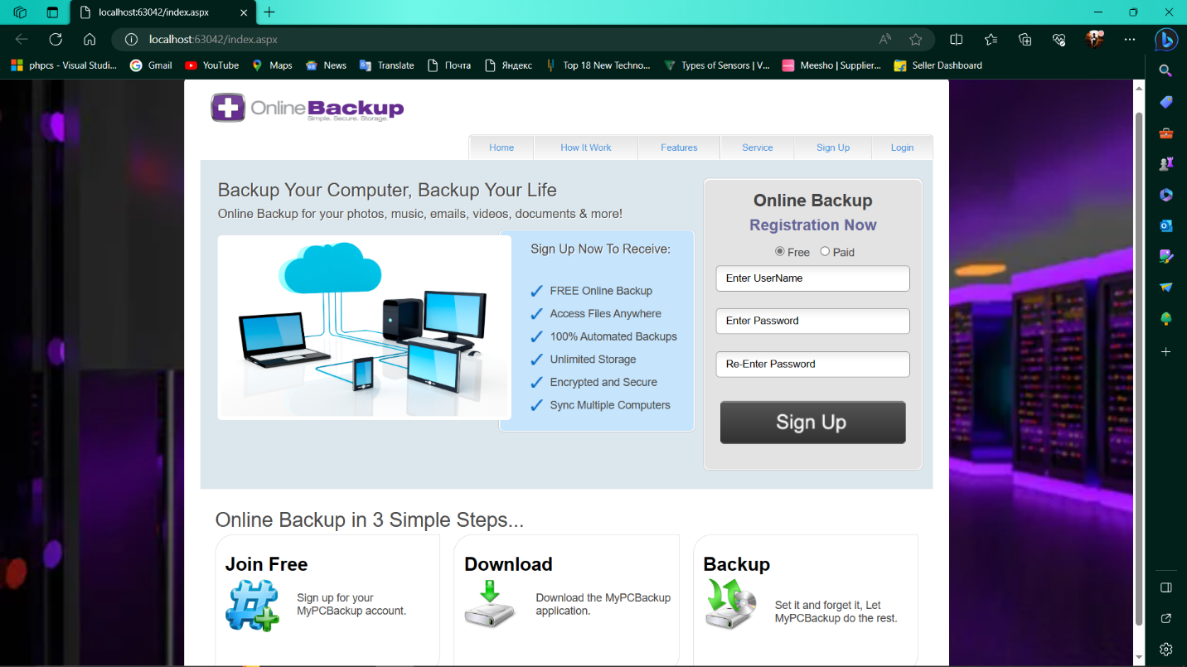

Login page :

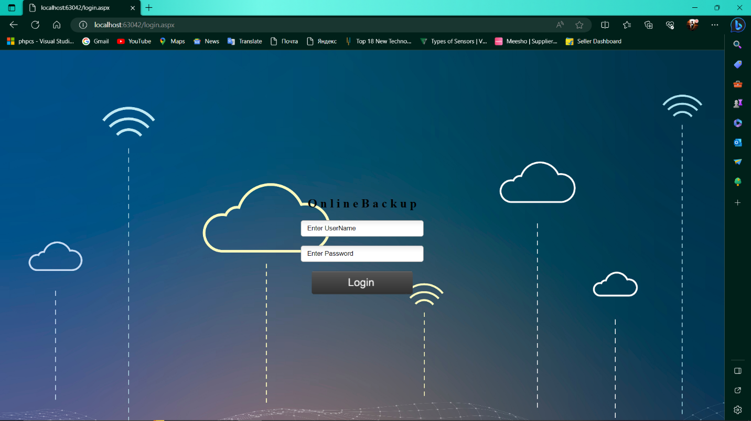

23

Registration Page :

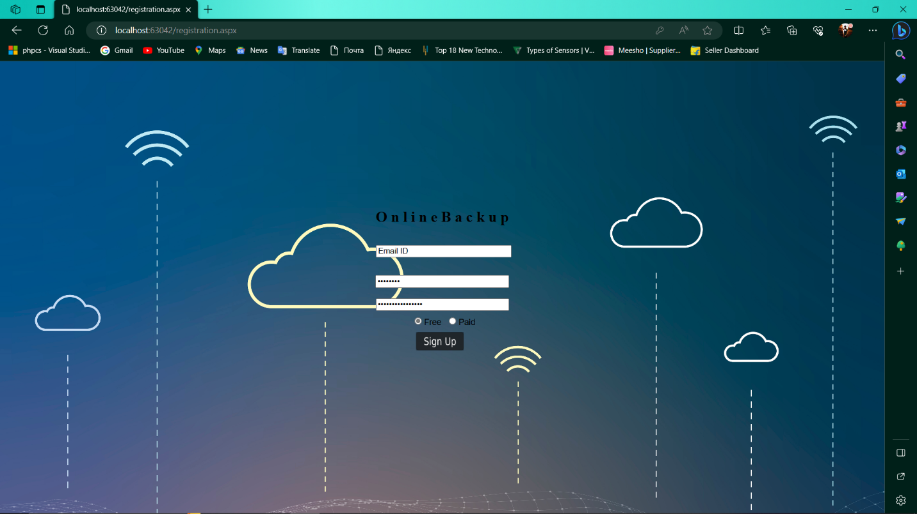

Home Page :

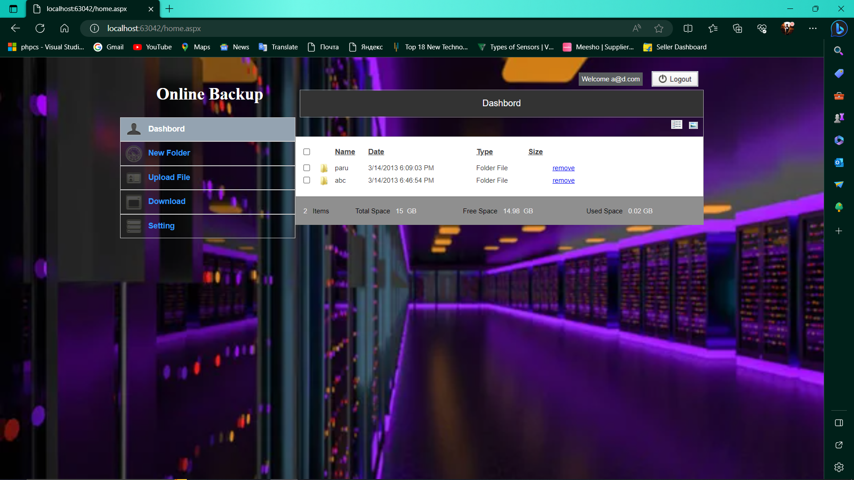

24

Folder Page :

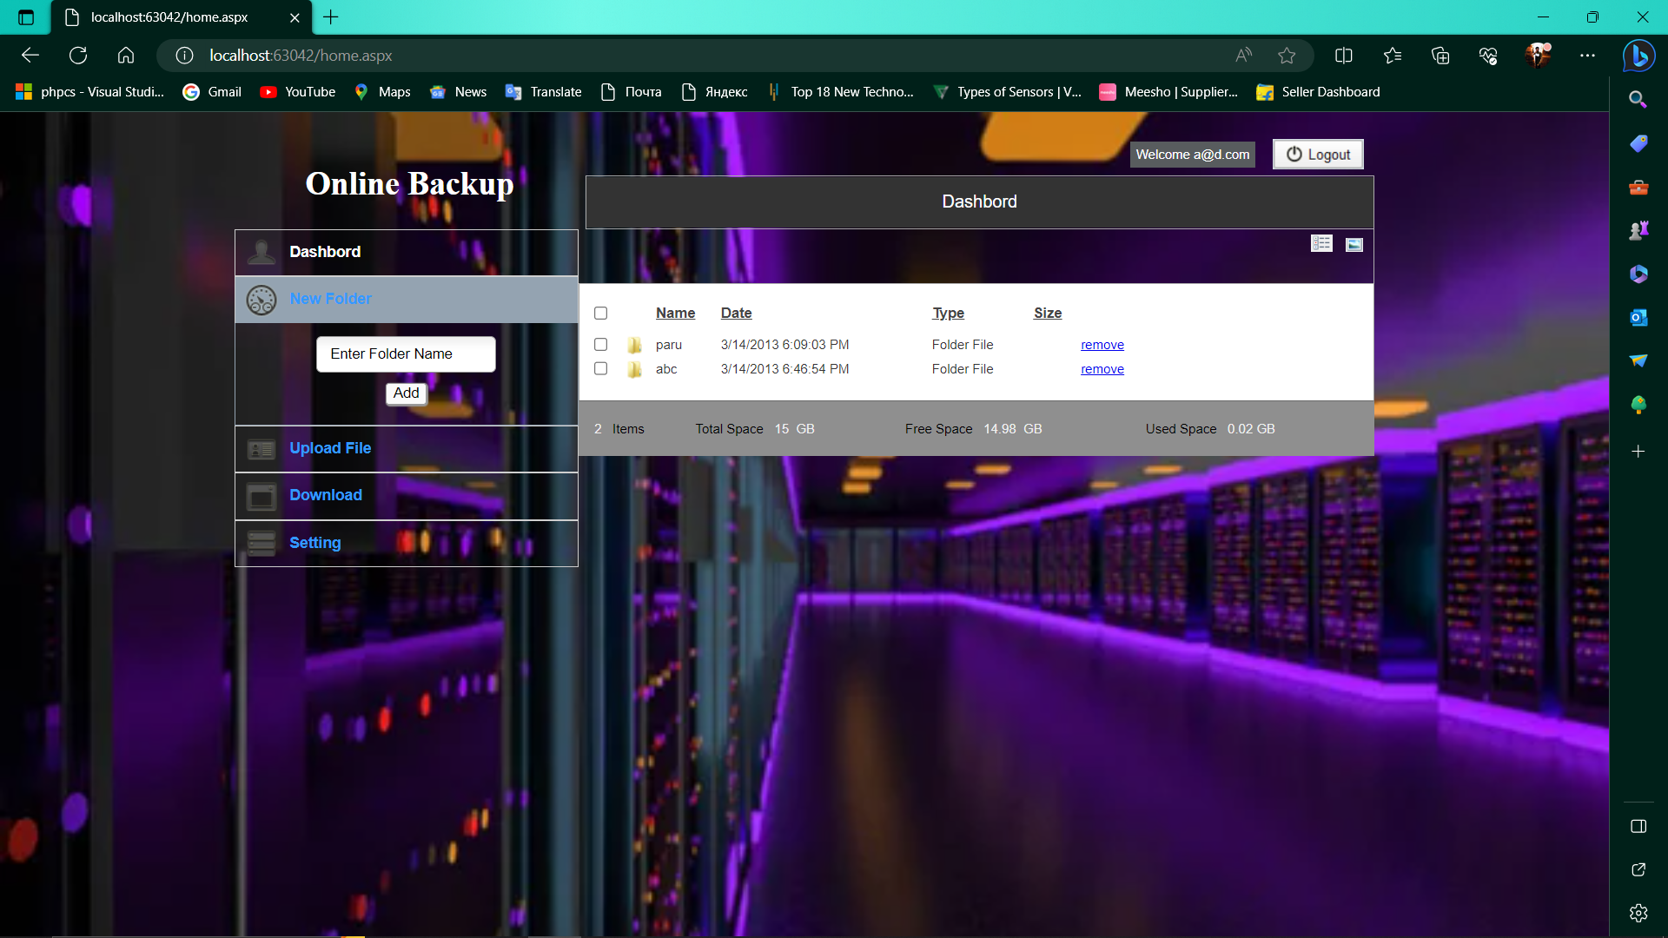

File Upload :

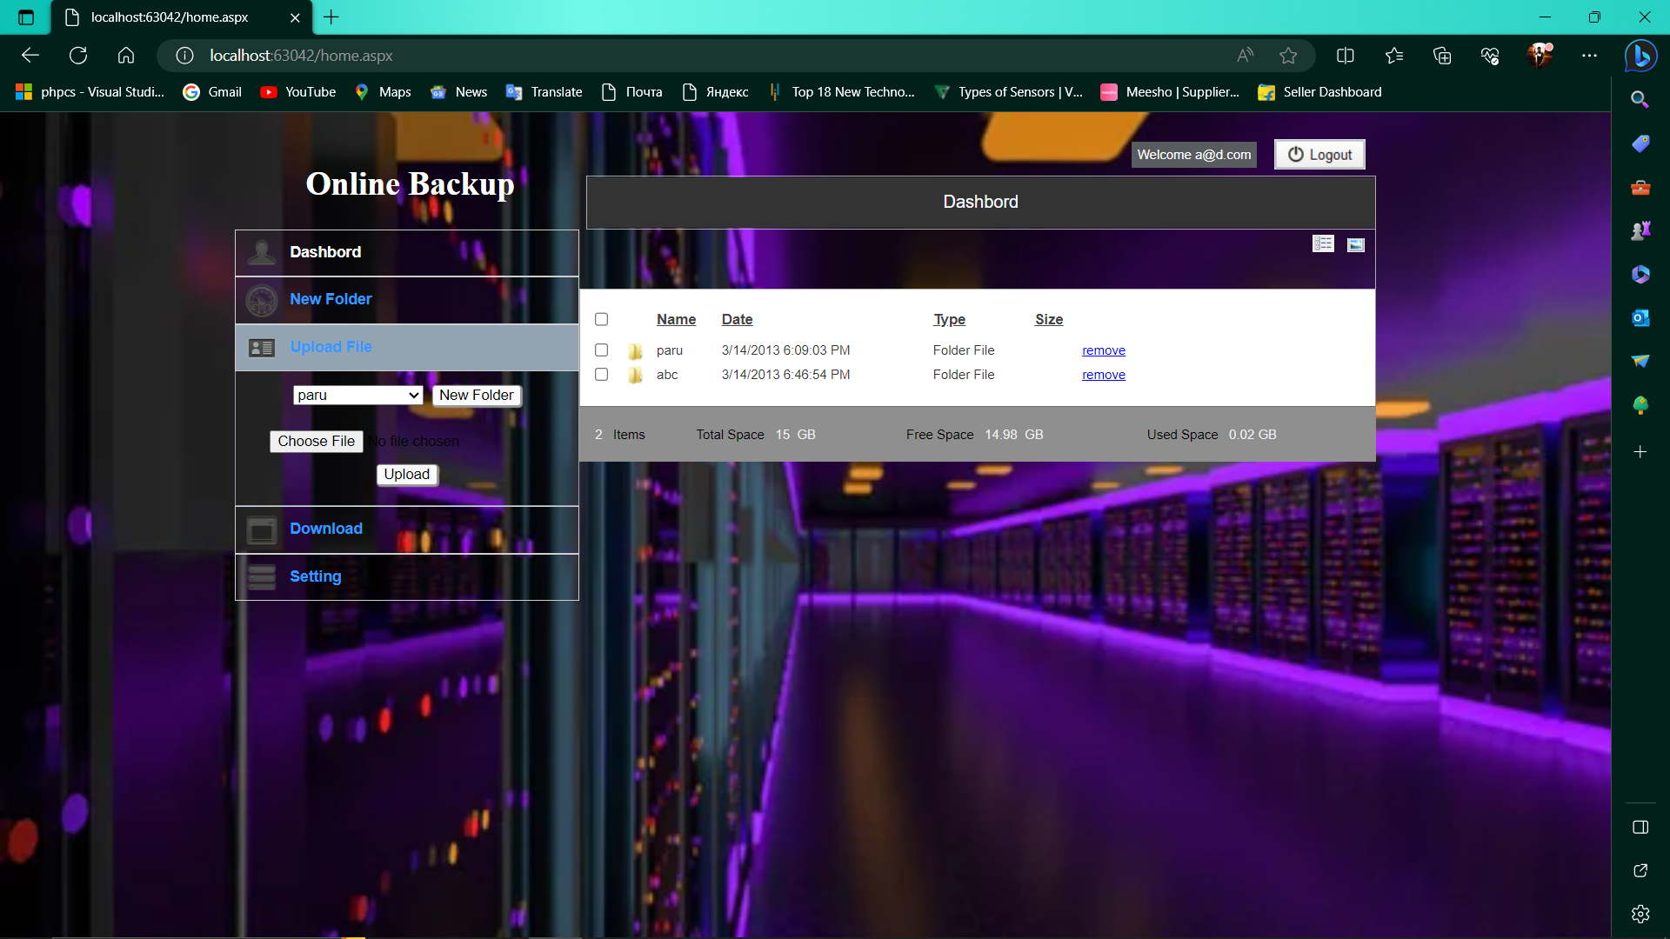

25

File Download :

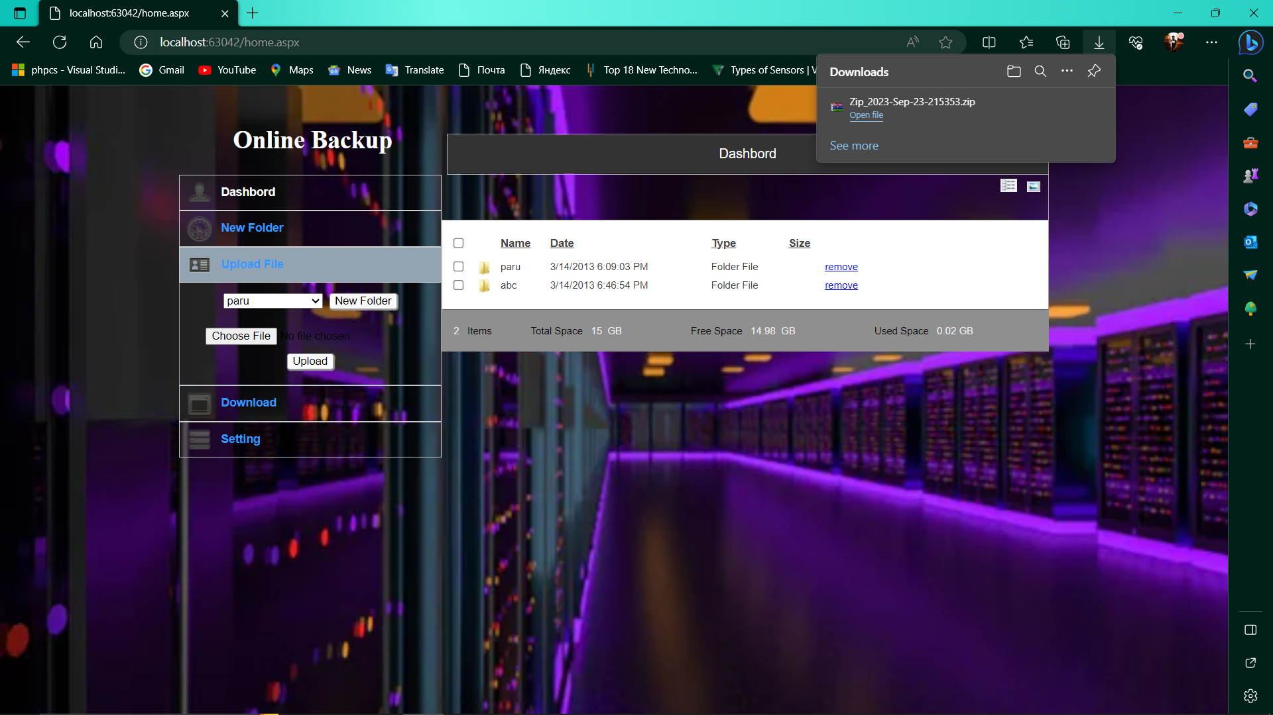

Plan Page :

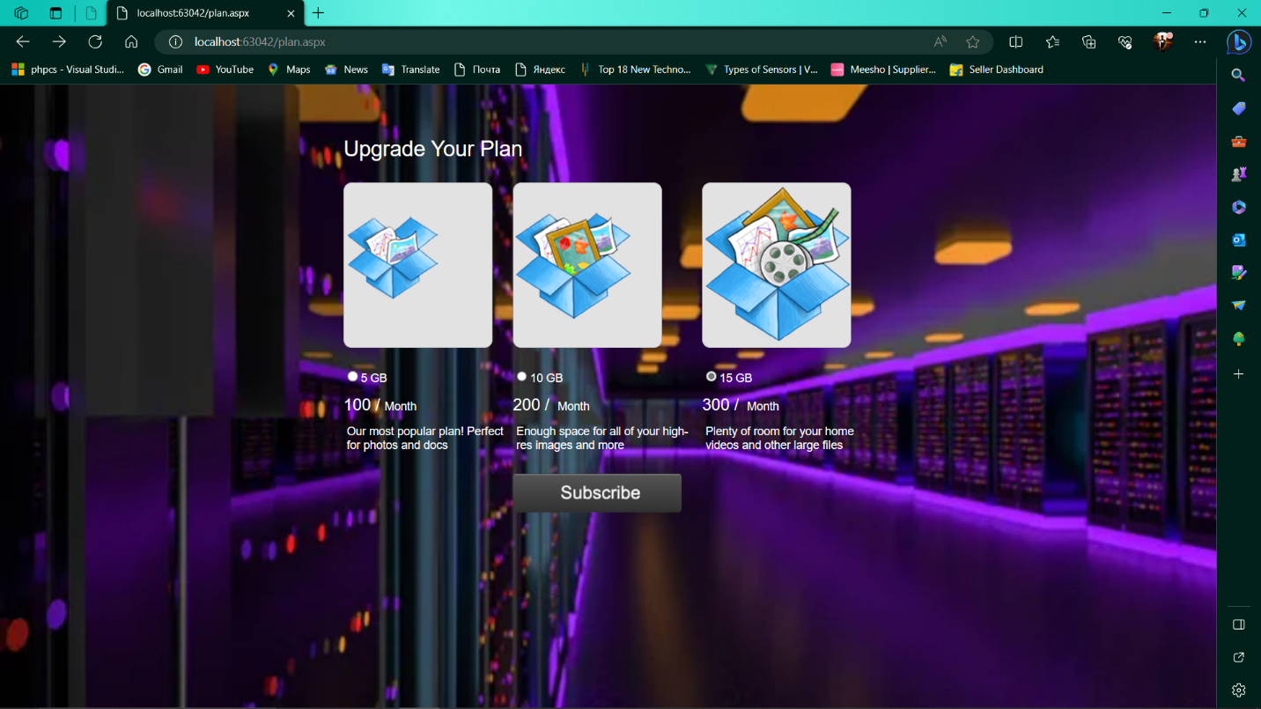

26

**Future Enhancement**

Enhancements for an online backup system can help improve its reliability, performance, and user experience. Here are some future enhancements to consider:

1. Artificial Intelligence (AI) and Machine Learning Integration
2. Blockchain for Data Integrity
3. Distributed and Decentralized Backups
4. Zero-Knowledge Encryption
5. Multi-Cloud Support
6. Continuous Data Protection
7. Hybrid Backup Solutions
8. Immutable Backups

27